Mouse Caprano CRISPR activation Screen

1. Objective

a. Mouse in vivo activation screen.

1. Reagent and Sample

a. Mouse sgRNA library (Addgene, Pooled Library #1000000113, #92383, #92384)

b. MC38 PD-L1 KO clonal cell line #1 (PX459-PD-L1, then transduced with Lenti-dCas9-VP64)

1. Procedure

**1) Caprano sgRNA library (**Total sgRNAs ~1.4x10^5 sgRNAs, ~46,000 genes x 6 sgRNAs, 500 unique non-targeting controls are in each of the two half-libraries (Set A and Set B)

**2) The sgRNA library (~4.6x10^4 genes, ~1.4x10^5 sgRNA)**

|  |  |  |
| --- | --- | --- |
| NO. | Genes Targeted | gRNAs |
| SetA | ~ 23,000 | ~68,000 |
| SetB | ~23,000 | ~67,000 |
| Total | ~46,000 | ~135,000 |

a. Seed 293T cell in 15cm dish (15cm dish x 30)

b. Transfection (Total plasmid 20ug/dish, fifteen 15cm dish for one sublibrary)

c. Medium change after 6 h transfection

d. ~48h after transfection, harvest and store lentivirus (~1.8ml virus/tube, 20 tubes; 10ml virus/tube)

**2) Lentiviral transduction and titer for MC38 cells**

a. For each lentivirus, seed 6 -well plate at a density of 1× 106 cells/well. In each well, add 800 µl, 400 µl, 200 µl, 100 µl, 50 µl or 0 µl of lentivirus supernatant (10ug/ml polybrene).

b. Medium change after 24 h.

c. After 48h, replate cells into 12-well plate (Add 100ul Trypsin then 900ul medium, then add 1ml PBS seeding 0.05M to the 12-well plate), and add 4ug/ml puromycin or not.

d. After 2~3day selection, test MOI by CTG.

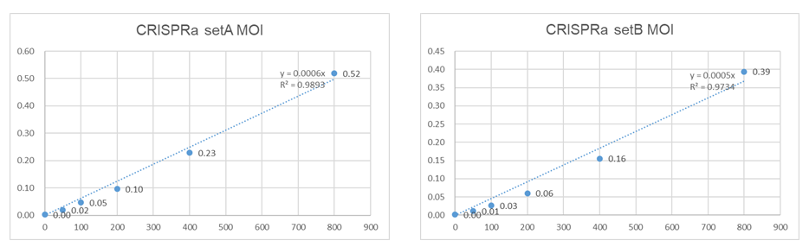

**3) Lentiviral transduction and screening**

a. Lentiviral sgRNA library transduction at ~0.3 MOI (SetA ~500ul/SetB ~650ul virus per well, twelve 6-well plates/library, 6x0.3=1.8M x12=21.6M ~300x coverage per sublibrary) (~5 dishes for SetA library).

b. After 24h, medium change.

c. After ~24h, replate cells into 15cm dish (4 wells into a 15cm dish, ~10M/dish, Every library divided into 6 sublibraries: e.g A1, A2…A6, two 6-well plates pool together as one sublibrary, 3x6=18 15cm dish/sublibrary; 第二天add 3ug/ml puro 细胞没怎么死, 1:1传代后加4ug/ml puro细胞死的较少，再次1:4传，每个库3个盘，每盘8M cell, add 6ug/ml puro,细胞死的较多)

d. Passage cells every 2~3 d (maintain at least 3.5M/dish/small sublibrary (~300X), A+B=12 dishes; b. For Total library, maintaining at least 14M cells(~200X), ~4 dishes/library. A+B=8dishes)

e. The puromycin selection for ~4days and maintain cells for ~10days (Total ~14 days after virus transduction).

**4) Harvest of genomic DNA for screening analysis**

a. Genomic DNA isolation by Chloroform/Methanol method (Mix the tumor powder from one sub-library)

b. Cell lysis buffer (10 mM Tris-HCl, pH 8.0, 100 mM EDTA, 0.5% SDS), 200 ug/ml RNase A @37˚C for 1 hr followed by the addition of 1 mg/ml of proteinase K @50˚C O/N.

c. The resulting lysates were extracted three times with phenol solution equilibrated with 10 mM Tris-HCl, pH 8.0, 1 mM EDTA mixed with chloroform (1:1 v/v) using tubes with phase lock gel。

d. The aqueous phase was then mixed with 0.2 vol of 10 M ammonium acetate and 1 vol of isopropanol, resulting the immediate formation of cloudy DNA precipitates.

e. Precipitated DNA was then transferred by a pipet tip to a tube containing 75% (v/v) ethanol. This process was repeated twice to ensure complete removal of residual organic solvents.

f. Afterwards, genomic DNA was dissolved in 1 mM Tris-HCl, pH 8.0, 0.1 mM EDTA by incubation at 50˚C for 3 hr.

**5) PCR amplification and next generation sequencing of sgRNAs**

a. Primers

|  |  |
| --- | --- |
| 1st PCR forward primer | 5’-CCTACACGACGCTCTTCCGATCTNNNNNNNNNNNNNNNNNN tgttttgagactataagtatcccttggagaacc-3’ |
| 1st PCR reverse primer | 5’-CAGACGTGTGCTCTTCCGATCTCCGACTCGGTGCCACTTTTTCAA-3’ |
| One of four indexed 2nd PCR forward primers | 5’- AATGATACGGCGACCACCGAGATCTACAC-8-nucleotide index-ACACTCTTTCCCTACACGACGCTCTTCCGATCT--3’ |
| One of four indexed 2nd PCR reverse primers | 5’-CAAGCAGAAGACGGCATACGAGAT-8-nucleotide index-GTGACTGGAGTTCAGACGTGTGCTCTTCCGATCT-3 |

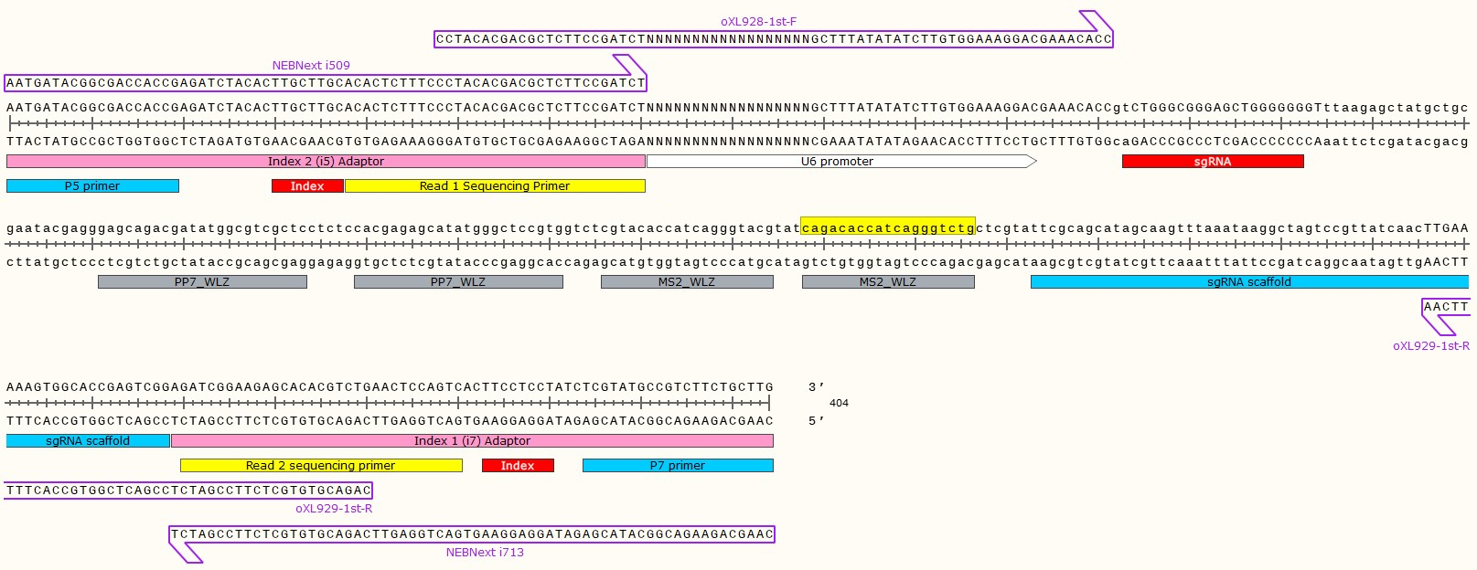

b. For the 1st round of PCR, ten 50 uL PCR reactions (20ug gDNA, ~2M cell, ~200x coverage)

|  |  |
| --- | --- |
| Component | Volume (ul) |
| 2x Q5 | 25 |
| Forward primer (10uM) | 5 |
| Reverse primer (10uM) | 5 |
| Genomic DNA | ~2ug |
| ddH2O | Up to 50 |

The thermal cycler program

|  |  |
| --- | --- |
| 98C, 30s |  |
| 98C, 10s | 20 cycles (Test cycle number) |
| 69C, 30s |
| 65C, 45s |
| 65C, 5min |  |

c. Products of the first-round PCR were pooled and purified by a DNA clean and concentrator kit (Magan, China) and diluted to 2 ng/mL.

d. For the 2nd round PCR, four 50uL PCR reactions were performed for each sample

|  |  |
| --- | --- |
| Component | Volume (ul) |
| 2x Q5 | 25 |
| Forward primer (10uM) | 5 |
| Reverse primer (10uM) | 5 |
| Purified 1st PCR product | 2ng |
| ddH2O | Up to 50 |

The thermal cycler program

|  |  |
| --- | --- |
| 98C, 5 min |  |
| 98C, 10s | 18 cycles (Test cycle number) |
| 69C, 30s |
| 65C, 45s |
| 65C, 5min |  |

e. Products of the 2nd round PCR reactions were subjected to electrophoresis on a 1.5% agarose gel. The

expected ~300 bp amplicons were excised and extracted from the gel and sequenced by Illumina

HiSeq PE150.